# U-Net: Convolutional Networks for Biomedical

# Image Segmentation

U-Net是在FCN的基础上提出的，结构如下：

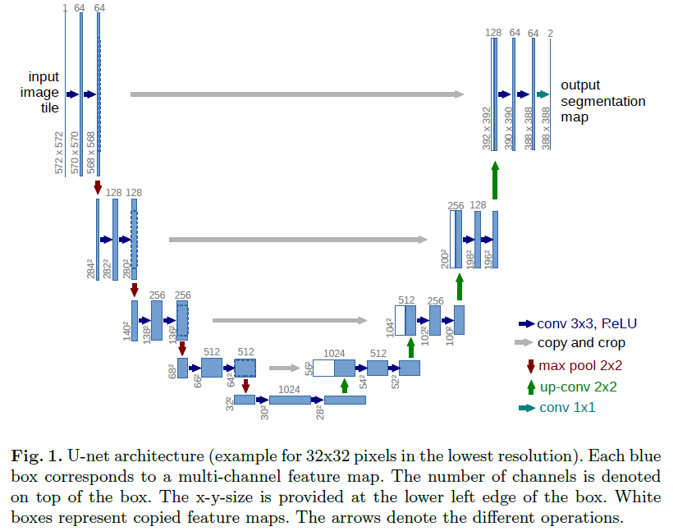

The network architecture is illustrated in Figure 1. It consists of a contracting

path (left side) and an expansive path (right side). The contracting path follows

the typical architecture of a convolutional network. It consists of the repeated

application of two 3x3 convolutions (unpadded convolutions), each followed by

a rectied linear unit (ReLU) and a 2x2 max pooling operation with stride 2 for downsampling. At each downsampling step we double the number of feature

channels. Every step in the expansive path consists of an upsampling of the

feature map followed by a 2x2 convolution (\up-convolution") that halves the

number of feature channels, a concatenation with the correspondingly cropped

feature map from the contracting path, and two 3x3 convolutions, each fol-

lowed by a ReLU. The cropping is necessary due to the loss of border pixels in

every convolution. At the final layer a 1x1 convolution is used to map each 64-

component feature vector to the desired number of classes. In total the network

has 23 convolutional layers.

如上图所示，这里我们假设U－ net 的最低分辨率为 32*32。每一个蓝色的块代表一个多通道的特征图。特征图的通道数被标注在块的顶部。X-Y尺寸设置在块的左下边缘。箭头代表着不同的操作。其中**左半部分是收缩路径，右半部分扩展路径**。

overlap-tile策略就是，要预测一个batch的标签，你必须输入比之大的一个框的图像，输入图像没有的部分，用****镜像法外推****。

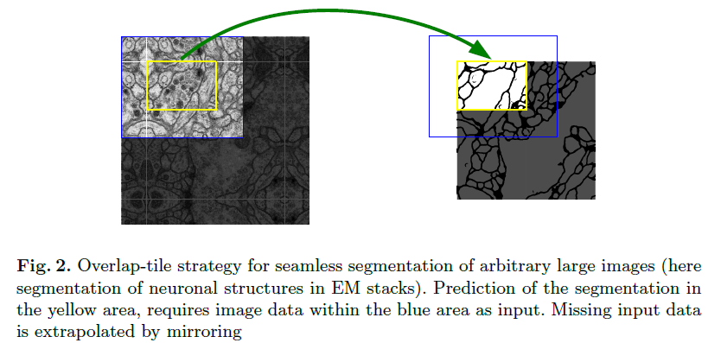

我们的任务中训练数据非常少，所以我们对仅有的数据进行****弹性形变操作****，以获得更多的数据。这样使得网络可以学习到形变特征。****生物医学图像****中****形变非常常见****。

另一个挑战是分割开连在一起的同种细胞，最终，我们提出使用****加权损失****，这样****分离****连在一起的细胞的label功能获得更大的权重。